Nashra Ghaffar (CT-20032)  
Muhammad Abdul Rafay (CT-20012)

Mahshid Fatima (CT-20023)  
Mehak Hussain (CT-20030)

Submitted To: Dr. Saman Hina

COMPILER DESIGN CCP

CT-465

Your text here

**Rubrics:**

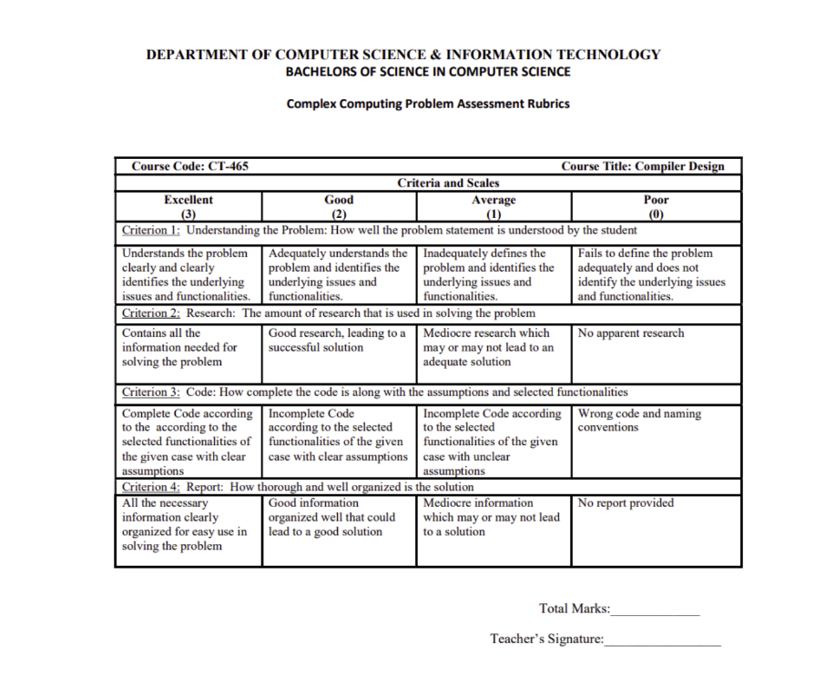

**Introduction:**

The JavaScript Function Compiler project aims to develop a compiler that meticulously handles JavaScript functions, including both normal (traditional) and arrow functions. By focusing on the structural and functional aspects of these functions, the compiler provides an in-depth understanding of how JavaScript processes function definitions, parameter handling, and return values.

We have built a custom JavaScript compiler using Python. This compiler performs lexical analysis, syntax analysis, semantic checks, and executes JavaScript function code. It supports both normal and arrow functions, manages parameters, and processes return values accurately. This project aims to provide a clear understanding of how JavaScript functions are compiled and executed, making it easier to learn and work with JavaScript functions.

**Functions in JavaScript**

In JavaScript, functions are fundamental building blocks. A function is a reusable block of code designed to perform a particular task. Functions can take inputs, called parameters, and return an output. They help in structuring and organizing code efficiently, allowing for modular and maintainable codebases.

**Types of Functions**

1. **Normal (Traditional) Functions:**

Normal functions, also known as traditional functions, are declared using the function keyword followed by a name, parameters, and a block of code. They are hoisted, meaning they can be called before their declaration in the code. This type of function has a dynamic this context, which refers to the object that calls the function, making it adaptable to different calling contexts.

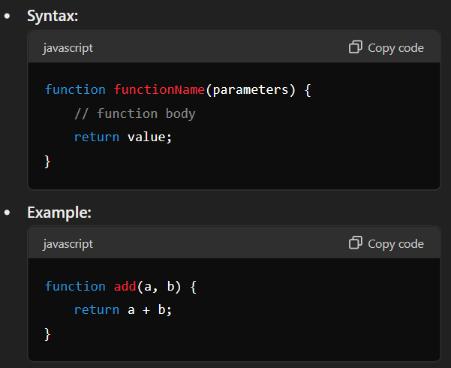

1. **Arrow Functions:**

Arrow functions are introduced in ES6 and provide a more concise syntax. They are defined using a pair of parentheses for parameters, followed by an arrow (=>) and the function body. Unlike normal functions, arrow functions are not hoisted and must be defined before they are used. A significant characteristic of arrow functions is their lexical binding of this, meaning they inherit this from the surrounding code where they are defined, making them particularly useful in scenarios requiring consistent this behavior, such as in callbacks and array methods.

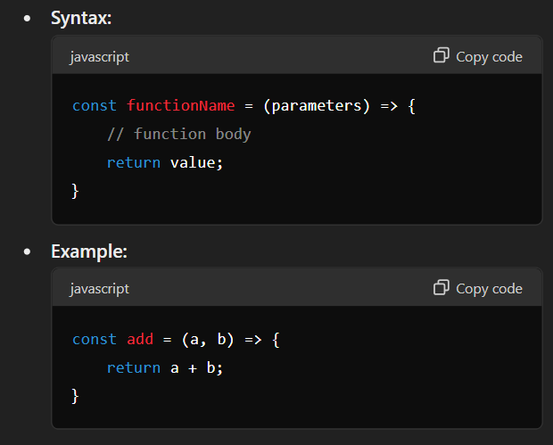

**Compiler Specifications:**

* 1. **Tokenization and Lexical Analysis:**

The compiler begins by tokenizing the user-provided JavaScript code using a set of predefined token types. These tokens include keywords (function, return, if, else, for, while, var, let, const), punctuation ((), {}, ,, ;), strings, numbers, and identifiers. Each token is categorized by its type, value, and corresponding line number to facilitate further processing.

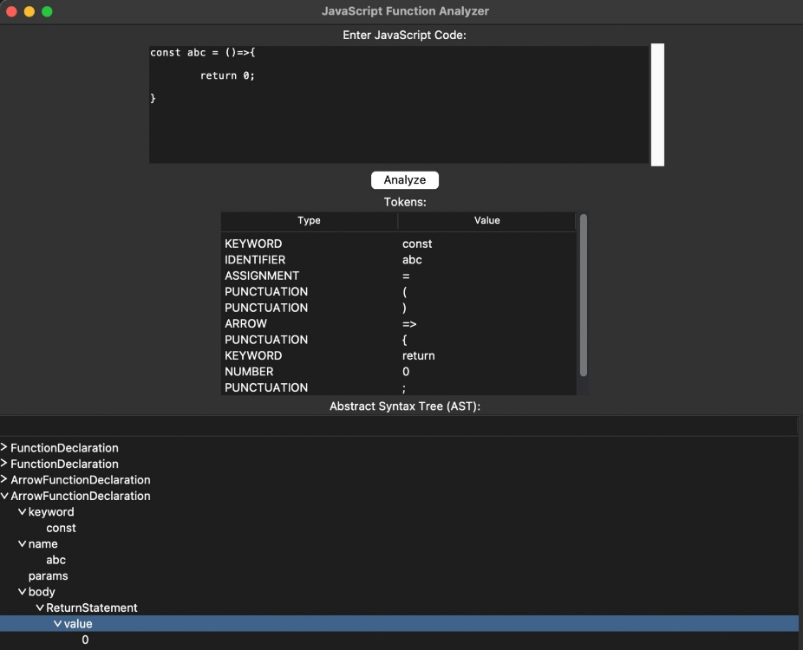

* 1. **Parsing (Syntactical Analysis)** :

After tokenization, the compiler parses the tokens into an Abstract Syntax Tree (AST). The parser identifies specific JavaScript constructs such as function declarations, and return statements. The AST structure organizes these constructs into a hierarchical format, representing the program's structure. This helps in understanding the logical flow and nested relationships of the code.



* 1. **Execution and Semantic Analysis:**

Once the AST is constructed, the compiler performs semantic analysis and executes the program. During semantic analysis, the compiler applies conditions for checking the naming conventions for identifiers according to JavaScript rules. This ensures that variable names, function names, and other identifiers follow the correct naming conventions, enhancing code quality and preventing common errors. Return statements within functions are analyzed to ensure they return a value.

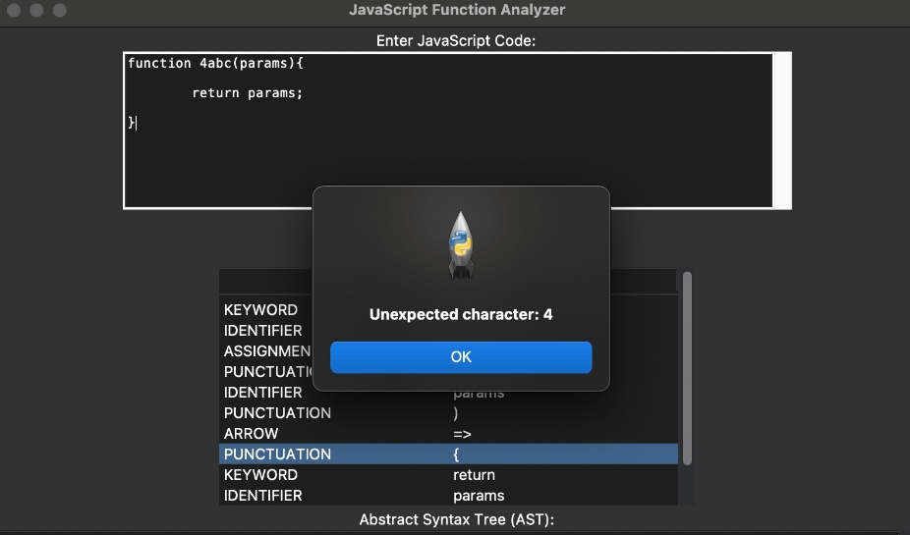

* 1. **Error Handling and Output**:

The compiler includes robust error-handling mechanisms to detect syntax errors, semantic errors (such as naming convention violations), and runtime errors during code execution. Errors are reported with informative messages, including the specific token or AST node causing the issue and its associated line number. This detailed error reporting aids in debugging and improving code quality.

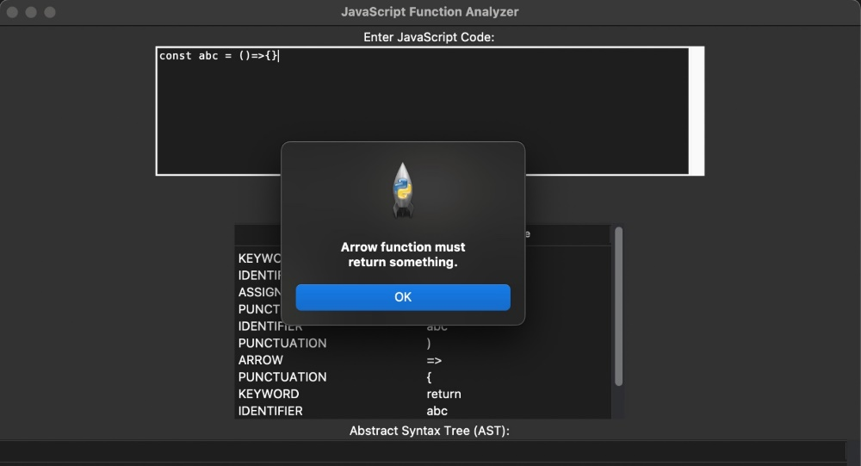

* 1. **Overall Implementation:**

We have designed a sophisticated compiler that efficiently handles function declarations, and return statements. The compilation process begins with tokenization, where the source code is broken down into meaningful symbols. Next, during syntactical analysis, the compiler checks the structure of these tokens to ensure they follow the correct syntax. Finally, semantic analysis verifies the logic and meaning of the code. Our compiler demonstrates the handling of JavaScript functions, including parameter management and return value processing, providing a comprehensive understanding of JavaScript's functional programming capabilities.

**Additional Features**

In addition to the core requirements, the compiler includes:

1. **Interactive Output Display:**

Provides a clear visualization of tokenized code, AST representation, and semantic analysis results through an interactive user interface.

1. **Real-time Feedback**:

As users input their code, the compiler provides real-time feedback on syntax errors and tokenization results. This immediate feedback loop helps users correct mistakes on the fly, leading to a more efficient and user-friendly coding experience.

**User Interface:**

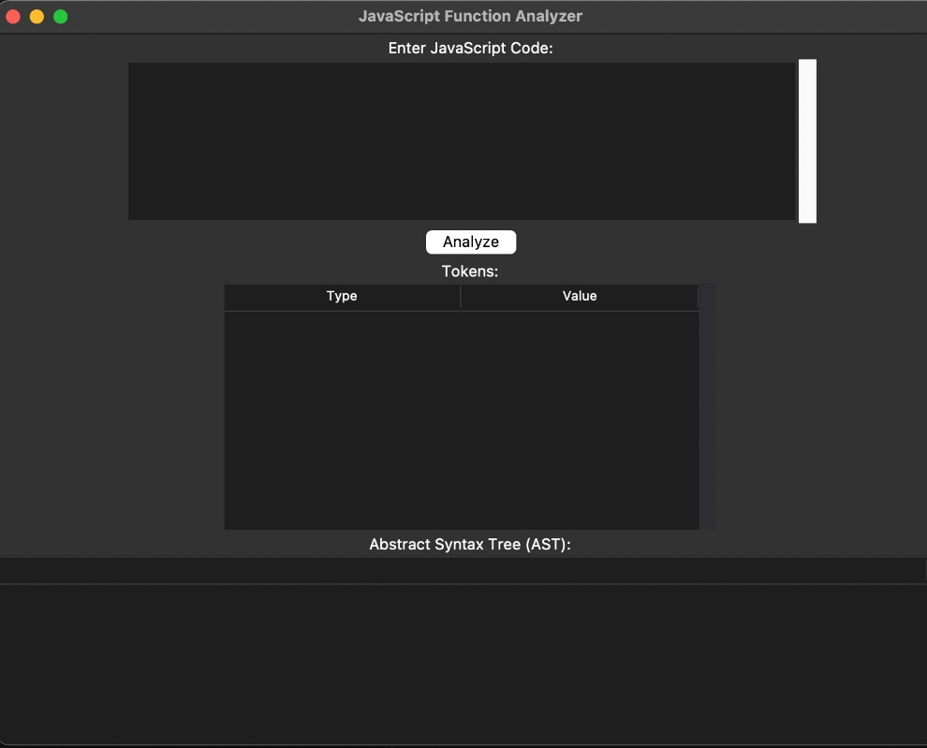

**Source Code:**

<https://github.com/sngwebs786/Compiler-for-JavaScript-Functions>

**Regular Expressions:**

1. **Identifier Naming converntion**

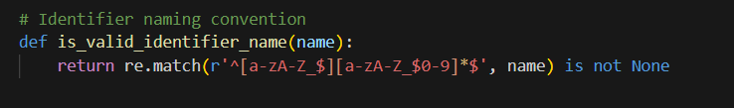

1. **Lexical Tokens**

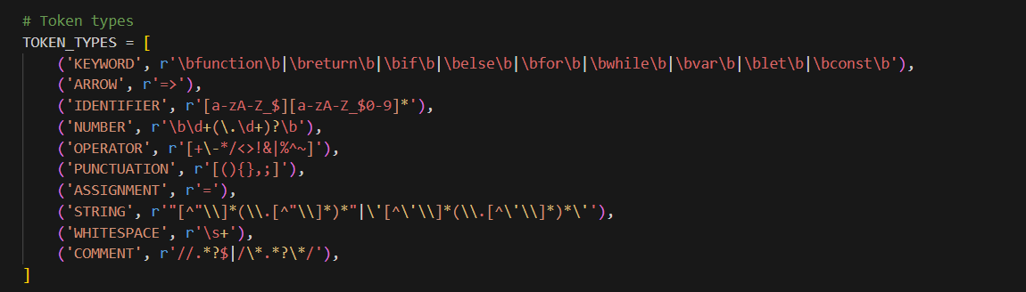

**Test Cases:**

1. **Arrow Function without return**

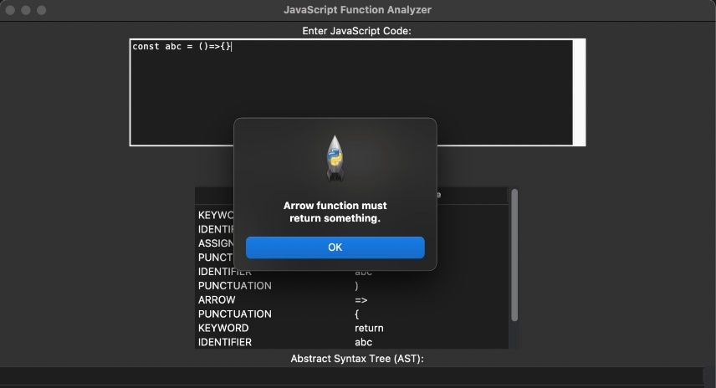

1. **Arrow Function with return**

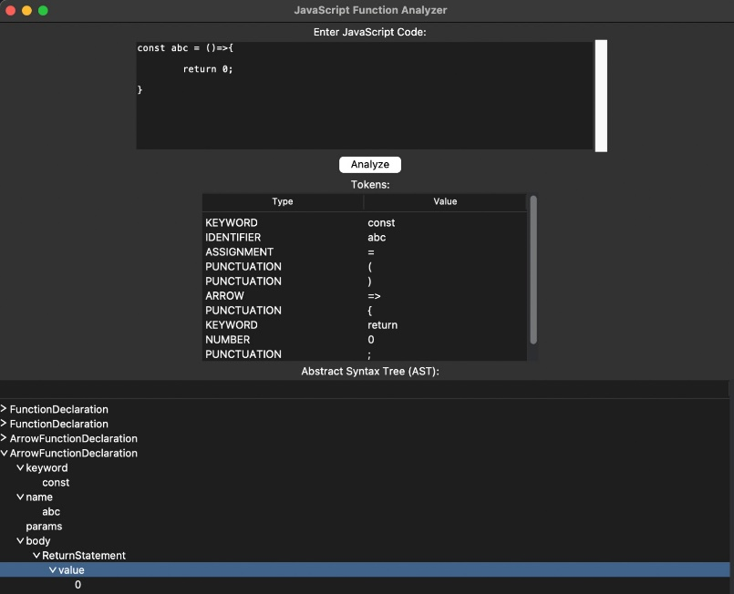

1. **Normal Function without return**

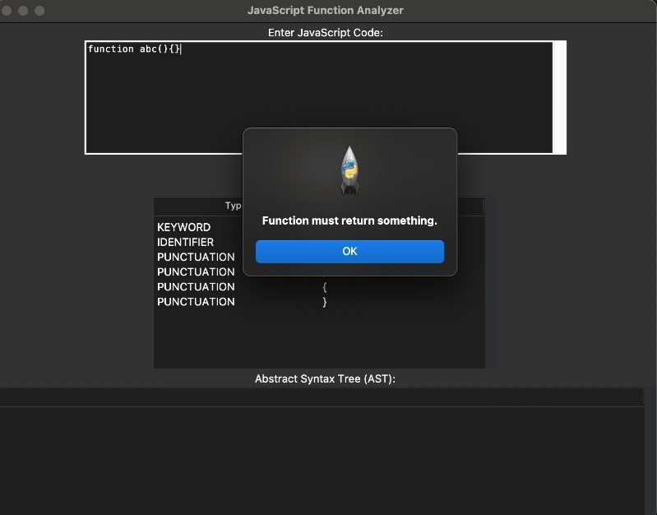

1. **Normal Function with return**

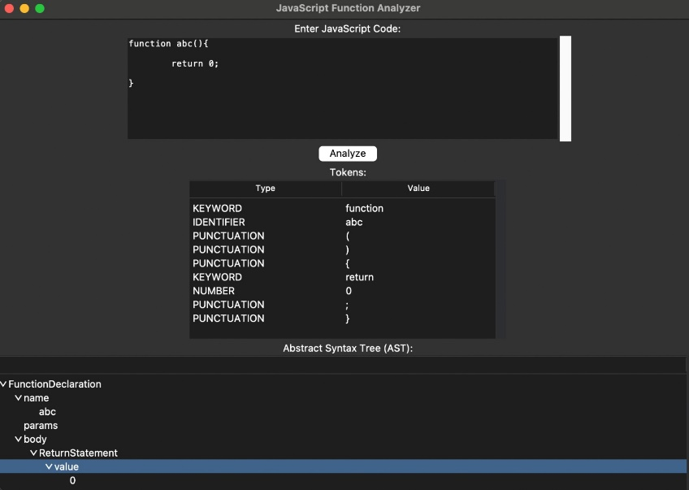

1. **Normal Function with Parameters**

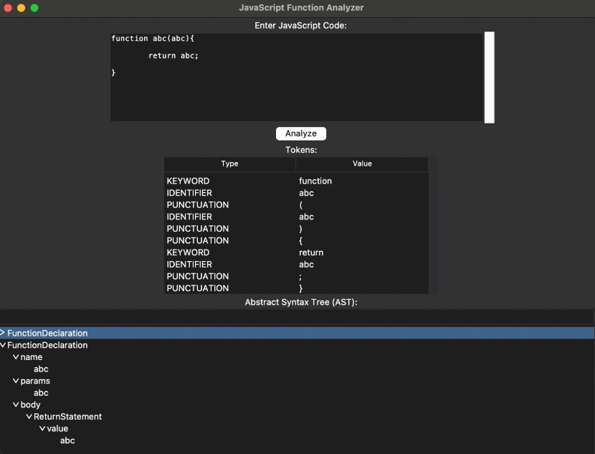

1. **Arrow Function with Parameters**

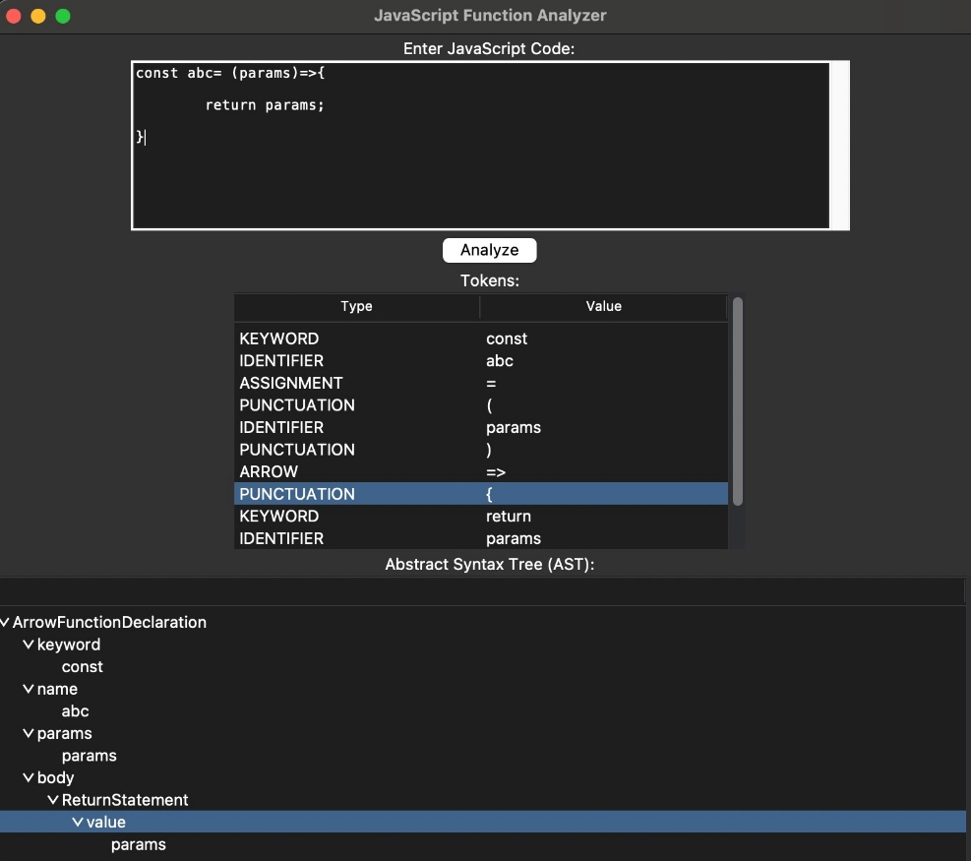

1. **Syntax Error**

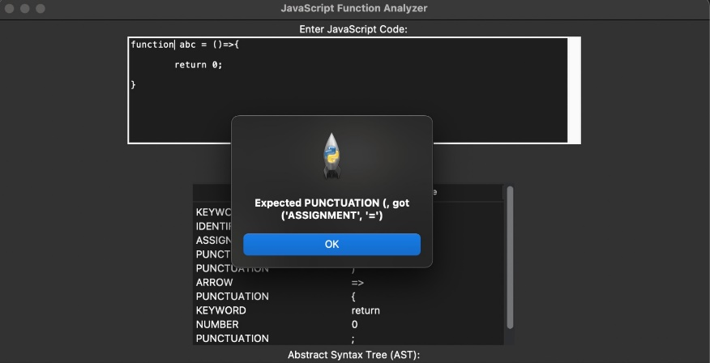

1. **Naming Convention Error (Normal Function)**



1. **Naming Convention Error (Arrow Function)**

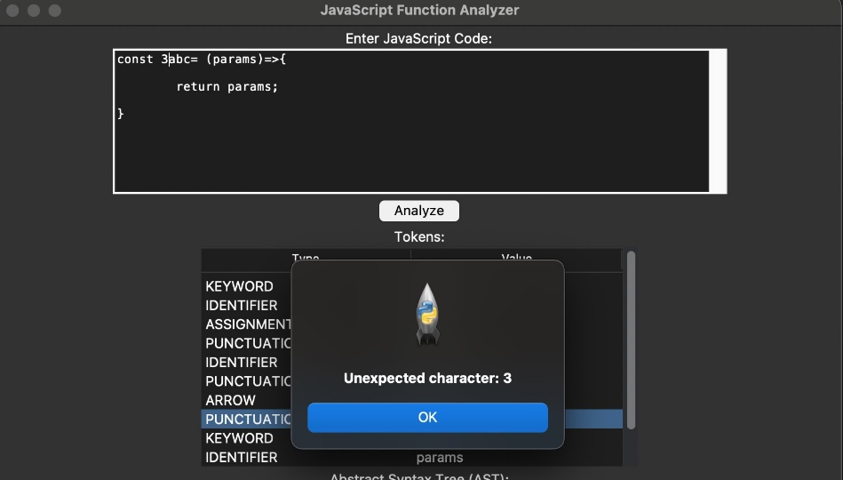

1. **Naming Convention Error (Parameter)**

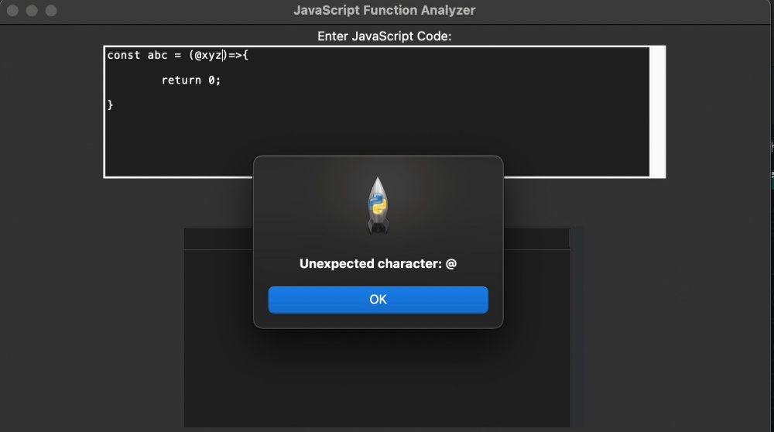

**Challenges:**

1. **Arrow Function Syntax and AST Interpretation**:

During the parsing and AST construction phase, the syntax for arrow functions such as const abc = () => {} posed a significant challenge. The presence of the = symbol led the parser to incorrectly interpret abc as a variable assignment rather than a function declaration. This misinterpretation caused the Abstract Syntax Tree (AST) to treat abc as a variable node instead of recognizing it as a function node.

1. **Detecting => as = and > operators:**

The compiler encountered a specific challenge in detecting arrow functions. It was incorrectly identifying the = as an assignment operator and the > as a separate operator, rather than recognizing the combined => as the arrow function syntax. This misinterpretation led to incorrect parsing and tokenization, causing the compiler to fail in recognizing and processing arrow functions accurately.

1. **Error Handling**:

Developing a robust error-handling mechanism in the compiler posed a significant challenge. When errors occurred in the JavaScript code, such as unexpected characters or missing return statements in functions, the compiler often reported generic errors like "index out of range" instead of providing clear, specific error messages. This made it difficult for users to identify and correct their mistakes, significantly hampering the debugging process.

**Limitations:**

1. **User Interface Focus**:

The project's user interface (UI) could benefit from more attention and refinement. While functional, additional time and effort could have enhanced the UI to provide a more intuitive and visually appealing experience for users. Improving the UI could facilitate better usability and navigation through the compilation process.

1. **Function Execution Scope**:

The current implementation does not execute the bodies of functions. Instead, the focus was primarily on parsing and analyzing function declarations, limiting the compiler's functionality to checking syntax and structure rather than simulating actual function behavior. Enhancing the compiler to execute function bodies would provide a more complete analysis of JavaScript code.

1. **Arrow Function Syntax (2nd way)**:

Although the compiler supports basic function declarations, it does not currently handle arrow functions another method. Arrow functions provide another concise syntax for defining functions and are widely used in modern JavaScript codebases.

**const abc = ( ) => return a;**

**Conclusion:**

In conclusion, the JavaScript Function Compiler project has successfully achieved its goal of developing a specialized compiler for handling JavaScript functions, encompassing both traditional and arrow function syntax. Throughout the project, emphasis was placed on meticulous handling of function definitions, parameter management, and accurate processing of return values.

By leveraging Python for implementation, the compiler seamlessly integrates lexical analysis, syntax parsing, semantic checks, and function execution. This comprehensive approach not only facilitates a deep understanding of JavaScript's function handling but also enhances the ability to analyze and execute JavaScript function code effectively.

Key accomplishments include the compiler's capability to manage function scope and enforce JavaScript naming conventions, thereby improving code reliability and adherence to best practices. While the current version focuses primarily on function compilation and execution, future iterations could expand to include broader JavaScript constructs and optimizations.

Overall, the JavaScript Function Compiler project serves as a valuable educational tool and practical resource for developers aiming to enhance their proficiency in JavaScript function programming. By providing insights into the inner workings of function compilation and execution, the compiler empowers users to write cleaner, more efficient JavaScript code in various application scenarios.